

**Bachelor Honours in Computer and Information Sciences**at The Independent Institute of Education

***Student Name and Surname***

***Yolisa Qadi***

**Student number**

**ST10472252**

**Module: AINT8412**

**Activity: ICE 5**  
Learning Unit 3: Convolutional Neural Networks

Malaria Detection Using Convolutional Neural Networks (CNNs)

Date: 30 September 2025

**Introduction**

Malaria remains one of the most severe global health threats, particularly in sub-Saharan Africa and Southeast Asia, where timely and accurate diagnosis is critical for effective treatment and control (Kabore & Guel, 2024; Kumar et al., 2024). Conventional diagnostic methods such as light microscopy and rapid diagnostic tests, while valuable, are constrained by limitations in scalability, accuracy, and accessibility—especially in resource-limited settings (Kabore & Guel, 2024; Jdey et al., 2022). With the advent of deep learning (DL) and machine learning (ML), automated malaria detection from blood smear images has become a promising avenue to improve diagnostic accuracy and efficiency (Taye et al., 2024; Kumar et al., 2024).

This ice task compares and contrasts contemporary deep learning pipelines for microscopy-based malaria detection, focusing on objective formulation, dataset preparation, model architecture, and training strategies. Drawing from recent literature and a practical Keras-based implementation, the discussion highlights key challenges, solutions, and insights, with an emphasis on reproducibility and real-world applicability.

**Objective Formulation in Automated Malaria Detection**

The primary objective of automated malaria detection systems is to enhance or replace manual microscopy by providing fast, scalable, and robust identification of malaria-infected cells from blood smear images (Kumar et al., 2024; Taye et al., 2024). State-of-the-art approaches aim not only for high accuracy but also for generalizability across different patient populations, imaging conditions, and geographic regions (Kabore & Guel, 2024). Recent studies, such as Tao and Han (2020), have further advanced these objectives by exploring unsupervised deep learning models to reduce labeling overhead, employing architectures like modified U-Net for cell segmentation and integrating chromatic analysis for infected cell identification.

Meanwhile, most deployed systems, including the referenced Keras/TensorFlow pipeline, focus on supervised classification using large annotated datasets, striving to maximize performance while minimizing overfitting and computational costs (Kumar et al., 2024; Taye et al., 2024). In sum, the field’s objectives have evolved from merely automating detection to addressing broader issues including data diversity, annotation variability, and model explainability to ensure clinical adoption (Kabore & Guel, 2024; Jdey et al., 2022).

**Dataset Preparation: Challenges and Solutions**

**Dataset Sources and Structure**

A critical component of developing reliable DL systems for malaria detection is the quality and structure of the training data. The National Institutes of Health (NIH) Malaria Dataset, comprising over 27,000 labeled images of parasitized and uninfected cells, has become a standard benchmark (Kumar et al., 2024; Taye et al., 2024; Jdey et al., 2022). This dataset, sourced from Giemsa-stained thin blood smear images collected in Bangladesh and annotated by expert microscopists, provides balanced class representation and high-resolution samples suited for training convolutional neural networks (CNNs). In the practical Keras-based pipeline described, the dataset is organized into folders for each class (‘Parasitized’ and ‘Uninfected’), and further split into training (80%) and testing (20%) subsets to facilitate model validation and mitigate overfitting. Data splitting is automated to ensure reproducibility and balance (Kumar et al., 2024).

**Data Quality and Diversity**

Despite the availability of large datasets, several challenges persist. Kabore and Guel (2024) highlight that class imbalance, limited diversity, and annotation variability can significantly hinder model performance and generalizability. For instance, models trained on regionally homogeneous data may underperform in other epidemiological contexts due to differences in blood smear preparation, staining protocols, or imaging equipment. To address these issues, advanced data augmentation techniques such as rotations, flips, zooming, and noise addition are applied during training, increasing the effective diversity of the dataset (Kabore & Guel, 2024; Taye et al., 2024). Synthetic data generation using Generative Adversarial Networks (GANs) has also been shown to improve class balance and model robustness by up to 20% in accuracy (Kabore & Guel, 2024).

**Preprocessing and Annotation**

Preprocessing steps, including resizing images to a consistent format (e.g., 64x64 pixels), normalization (scaling pixel values to [0,1]), and color space conversion, are essential for both computational efficiency and model convergence (Kumar et al., 2024; Taye et al., 2024). Annotation quality is ensured through expert review and, where possible, standardized guidelines (Kabore & Guel, 2024). By integrating these data preparation strategies, pipelines can mitigate biases, enhance the representation of minority classes, and support model generalization across diverse clinical settings.

**Model Architecture: Design Choices and Innovations**

**Convolutional Neural Networks (CNNs)**

CNNs are the backbone of most modern image-based malaria detection systems. Their architecture, inspired by the animal visual cortex, enables hierarchical feature extraction directly from raw pixel data, obviating the need for manual feature engineering (Kumar et al., 2024; Jdey et al., 2022).

The practical Keras implementation employs a sequential CNN with three convolutional layers of increasing depth (32, 64, 128 filters), each followed by max pooling, culminating in a flattening layer and two fully connected layers (the latter with dropout regularization) before a sigmoid-activated output for binary classification. This structure allows the model to learn both low-level (edges, textures) and high-level (cell morphology, parasite presence) features (Kumar et al., 2024). Sumit Kumar et al. (2024) demonstrate that even shallow CNNs comprising as few as two convolutional layers can achieve state-of-the-art accuracy (95.4% on NIH test data), provided hyperparameters are tuned appropriately. This minimalistic approach is particularly advantageous for deployment on mobile or resource-constrained devices.

**Transfer Learning and Pretrained Models**

To further enhance performance and generalizability, transfer learning with pretrained architectures (e.g., VGG19, InceptionV3, Xception) is widely adopted (Taye et al., 2024; Jdey et al., 2022). Utilizing models initially trained on large, diverse datasets like ImageNet, transfer learning enables the rapid adaptation of robust feature extractors to the malaria detection task, often yielding higher accuracy and faster convergence (Taye et al., 2024). For example, Taye et al. (2024) report that deep CNNs achieve 97% accuracy on the NIH malaria dataset, surpassing traditional machine learning models like SVM (83%) and even advanced architectures such as Xception (95%). The combination of transfer learning and fine-tuning is particularly effective when local datasets are small or of lower quality.

**Unsupervised and Hybrid Approaches**

Recent innovations include unsupervised learning models, such as the modified U-Net architecture proposed by Tao and Han (2020), which perform cell boundary segmentation without extensive manual labeling. By leveraging chromaticity analysis (e.g., Mahalanobis distance in HSV space), these methods can identify infected cells with minimal annotation, offering a promising alternative to purely supervised pipelines in settings where labeled data is scarce. Hybrid models that combine CNN-based feature extraction with classical ML classifiers (e.g., SVM, KNN) have also been explored, sometimes improving performance and interpretability (Jdey et al., 2022).

**Training Strategies and Evaluation**

**Training Protocols**

Training CNNs for malaria detection involves iterative optimization of model weights using backpropagation and stochastic gradient descent variants, such as Adam (Kumar et al., 2024; Tao & Han, 2020). Loss functions like binary or categorical cross-entropy are standard, measuring the divergence between predicted and true labels. In the Keras pipeline, key training strategies include early stopping (to halt training when validation accuracy plateaus), model check pointing (to save the best performing model), and dropout regularization (to prevent overfitting). Batch normalization is used to stabilize learning and accelerate convergence (Kumar et al., 2024).

**Data Augmentation and Balancing**

To combat class imbalance and overfitting, data augmentation is systematically applied during training. Techniques such as random rotations, translations, zooms, and flips help simulate real-world variability and increase the network’s exposure to diverse input patterns (Kabore & Guel, 2024; Taye et al., 2024). Advanced methods such as class-weighted loss functions, focal loss, oversampling, and GAN-based synthetic data generation further improve sensitivity and specificity, particularly for the minority (infected) class (Kabore & Guel, 2024; Jdey et al., 2022).

**Validation and Testing**

Model evaluation is performed on held-out test sets, with metrics including accuracy, precision, recall, F1-score, and confusion matrices. In the referenced implementation, the pipeline reports training and validation loss/accuracy curves, final test set performance, and confusion matrices to provide a comprehensive assessment (Kumar et al., 2024). Sumit Kumar et al. (2024) observed that with early stopping and appropriate regularization, their two-layer CNN achieved 95.4% test accuracy without significant overfitting. Taye et al. (2024) reported that transfer learning models like VGG19 and InceptionV3 consistently outperformed traditional CNNs and SVMs, highlighting the value of leveraging pretrained architectures.

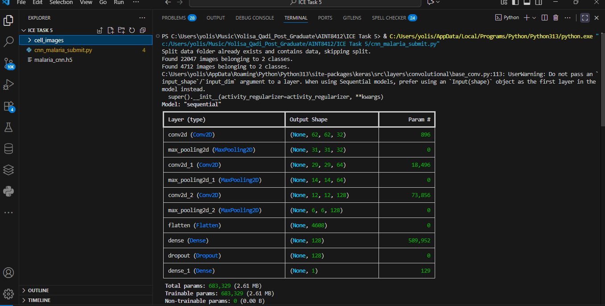

**Explainability and Clinical Integration**

While high accuracy is essential, explainability and clinical trustworthiness are increasingly recognized as prerequisites for real-world adoption (Kabore & Guel, 2024). Visualization techniques such as saliency maps or class activation mappings—can help elucidate model decisions and promote clinician confidence. Collaborative dataset development and data-sharing frameworks are also critical for building equitable, reliable diagnostic tools.

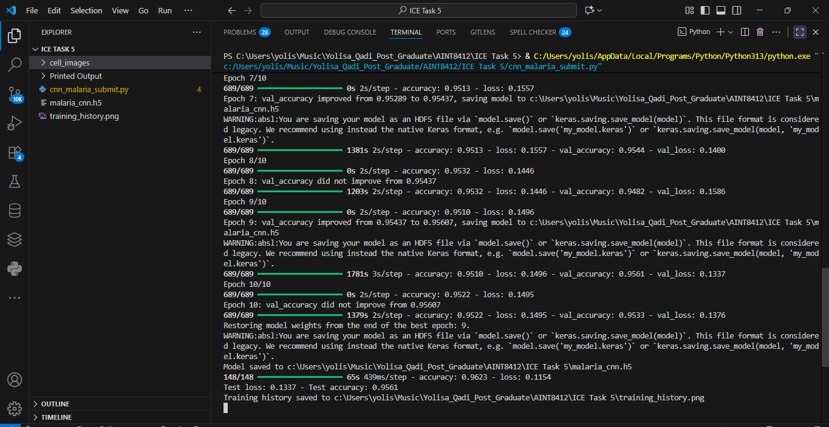

**Key Insights and Comparative Analysis**

**Strengths of Contemporary Pipelines**

High Accuracy and Scalability in Deep CNNs, particularly those leveraging transfer learning, achieve state-of-the-art accuracy (>95%) on benchmark datasets such as the NIH malaria cell images (Kumar et al., 2024; Taye et al., 2024). Efficiency and Adaptability in Minimalistic architectures (e.g., two-layer CNNs) offer competitive performance with reduced computational requirements, facilitating deployment in resource-constrained settings (Kumar et al., 2024). Automated Feature Extraction in CNNs obviate the need for manual feature engineering, learning hierarchical representations directly from raw images (Jdey et al., 2022).

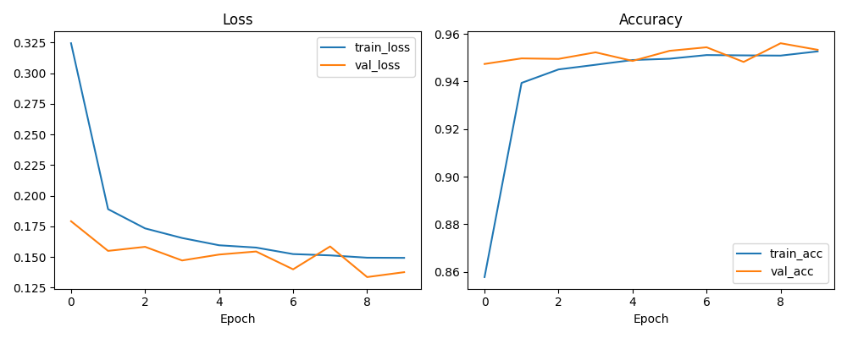

Public repository of my files: <https://github.com/Yolisaq/Malaria_CNN_Pipeline.git>

**Persistent Challenges**

Data Quality and Generalization in Class imbalance, limited dataset diversity, and annotation variability remain significant obstacles to clinical robustness (Kabore & Guel, 2024). Model Overfitting and Bias without careful data augmentation and regularization, models risk overfitting to training distributions, reducing their utility in novel settings (Kabore & Guel, 2024; Jdey et al., 2022). Explainability of black-box models hinder clinician adoption; thus, efforts to improve model interpretability and transparency are vital (Kabore & Guel, 2024).

**Innovations and Future Directions**

Unsupervised and Semi-supervised Learning: Techniques that reduce reliance on labeled data, such as self-training U-Nets or GAN-based augmentation, are increasingly important for scalability (Tao & Han, 2020; Kabore & Guel, 2024). Collaborative Data Sharing: Building globally diverse, well-annotated datasets will support generalizable, equitable AI-driven diagnostics (Kabore & Guel, 2024). Web-based and Mobile Deployment: Integrating DL pipelines into web or mobile platforms can democratize access to high-quality diagnostics (Taye et al., 2024).

**Conclusion**

Deep learning has revolutionized the field of automated malaria detection, offering unprecedented accuracy and efficiency compared to traditional microscopy. Careful attention to dataset preparation, model architecture, and training strategy is essential to maximizing both accuracy and generalizability. While significant progress has been made, persistent challenges around data quality, annotation variability, and clinical integration remain. Future research must focus on developing robust, explainable models that can adapt to diverse clinical environments, leveraging unsupervised learning, advanced data augmentation, and collaborative frameworks. By addressing these challenges, AI-driven malaria diagnostics can become a cornerstone in the global fight against malaria, particularly in resource-constrained settings.

**References**

Kabore, K. K., & Guel, D. (2024). Addressing challenges in data quality and model generalization for malaria detection. Journal of Sensor Networks and Data Communications (JSNDC). <http://arxiv.org/pdf/2501.00464v1>

Jdey, I., Hcini, G., & Ltifi, H. (2022). Deep learning and machine learning for malaria detection: overview, challenges and future directions. International Journal of Information Technology & Decision Making. <http://arxiv.org/pdf/2209.13292v1>

Kumar, S., Vardhan, H., Priya, S., & Kumar, A. (2024). Malaria detection using Deep Convolution Neural Network. <http://arxiv.org/pdf/2303.03397v2>

Tao, A., & Han, B. (2020). Deep unsupervised learning for microscopy-based malaria detection. <http://arxiv.org/pdf/2009.00197v1>

Taye, A. G., Yemane, S., Negash, E., Minwuyelet, Y., Abebe, M., & Asmare, M. H. (2024). Automated web-based malaria detection system with machine learning and deep learning techniques. <http://arxiv.org/pdf/2407.00120v1>

Malaria Vaccine Initiative. (n.d.). Malaria parasite life cycle. https://www.malariavaccine.org/tools-resources/malaria-parasite-life-cycle

TensorFlow. (n.d.). Convolutional neural network (CNN) tutorial. <https://www.tensorflow.org/tutorials/images/cnn>

Towards Data Science. (n.d.). Coding a convolutional neural network (CNN) using Keras Sequential API. <https://towardsdatascience.com/coding-a-convolutional-neural-network-cnn-using-keras-sequential-api-ec5211126875/>